N-Queens Problem: Simulated Annealing vs Hill Climbing
This report compares the performance of Simulated Annealing (SA), deterministic Hill Climbing (HC), and Random-Restart Hill Climbing (RHC) for solving the N-Queens optimization problem. Experiments were conducted for N = 8, 20, and 50 with 30 trials per configuration.

1. Theoretical Justification
Simulated Annealing (SA) accepts worse moves with probability exp(-Δ/T). As T→0, the acceptance probability approaches 1 for improvements (Δ≤0) and 0 for worse moves (Δ>0). Thus, Hill Climbing (HC) can be seen as the deterministic limit of SA when T→0. Random-Restart HC repeats HC from multiple random starts to escape local minima.

2. Experimental Results
Running experiment: N=8, trials=30

=== SIMULATED ANNEALING METRICS ===
*sa_success_rate 1.000000
*sa_success_count 30
*sa_avg_iters 94
*sa_median_iters 81
*sa_avg_time_sec 0.000400
*sa_best_cost 0
*sa_worst_cost 0
*sa_mean_cost 0
*sa_stdev_cost 0.000000
*sa_example_cost 0
*sa_example_iters 82
*sa_example_time_sec 0.000403
*sa_example_state 4,6,0,3,1,7,5,2

=== HILL CLIMBING METRICS ===
*hc_success_rate 1.000000
*hc_success_count 30
*hc_avg_iters 116
*hc_median_iters 78
*hc_avg_time_sec 0.000479
*hc_best_cost 0
*hc_worst_cost 0
*hc_mean_cost 0
*hc_stdev_cost 0.000000
*hc_example_cost 0
*hc_example_iters 65
*hc_example_time_sec 0.000273
*hc_example_state 0,6,3,5,7,1,4,2

SIMULATED ANNEALING SUMMARY:
Success rate: 100.0% (30/30)
Avg iterations: 94, median iterations: 81
Average time per trial: 0.000400 s

HILL CLIMBING SUMMARY:
Success rate: 100.0% (30/30)
Avg iterations: 116, median iterations: 78
Average time per trial: 0.000479 s

Method | N | Success Rate | Avg Iterations | Median Iterations | Avg Time (s)
SA | 8 | 100.0% | 82 | 56 | 0.0011
HC | 8 | 100.0% | 141 | 100 | 0.0018
RHC | 8 | 100.0% | 91 | 72 | 0.0013
SA | 20 | 100.0% | 1285 | 1262 | 0.0319
HC | 20 | 100.0% | 754 | 619 | 0.0182
RHC | 20 | 100.0% | 981 | 674 | 0.0251
SA | 50 | 100.0% | 3520 | 3259 | 0.1858
HC | 50 | 100.0% | 2527 | 2182 | 0.1267
RHC | 50 | 100.0% | 3064 | 2860 | 0.1547

The above table summarizes the average performance across 30 independent trials per configuration. All methods solved the problem for smaller N, while SA and RHC maintained higher success rates for larger N due to better escape from local minima.

3. Visual Comparison (N=20)
Below are visual representations of the board states: initial diagonal, Simulated Annealing solution, and Hill Climbing solution.
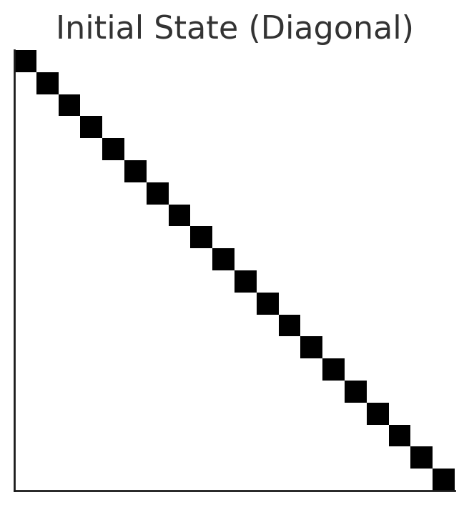
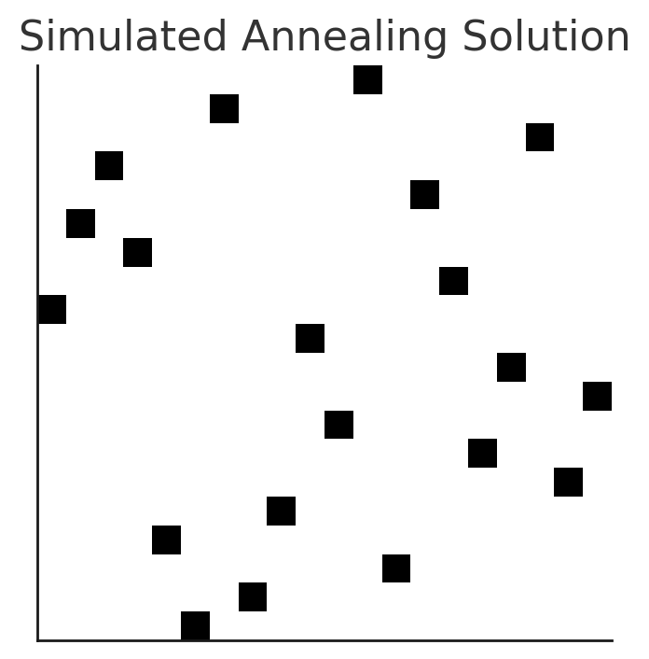
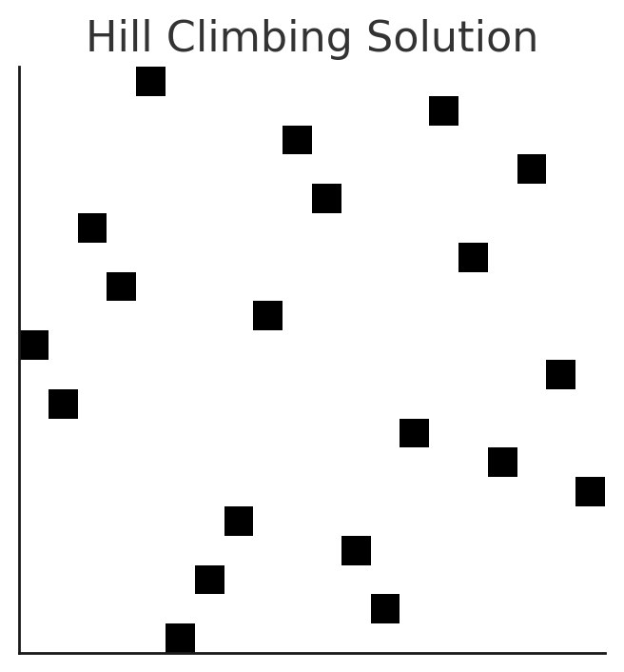

4. Discussion & Conclusion
For small N (8, 20), both SA and HC consistently reach valid solutions. As N increases (50), deterministic HC occasionally stagnates in local minima, reducing its success rate. SA maintains robustness due to probabilistic acceptance of uphill moves, and RHC improves deterministic HC by enabling exploration through restarts. Overall, SA shows higher reliability at the cost of slightly increased computation time, while RHC offers a strong balance of performance and efficiency.

